Implement and manage Zero Trust Network Access (ZTNA) using Zscaler

S.no | Name | College | Contact
1 | Madhurasree R | Sri Ramakrishna college of arts and science for women | srcw2322k124@srcw.ac.in
2 | Ramu G | Sri Ramakrishna college of arts and science for women | srcw2322k143@srcw.ac.in
3 | Sarumathi C | Sri Ramakrishna college of arts and science for women | srcw2322k147@srcw.ac.in
4 | Monisha M | Sri Ramakrishna college of arts and science for women | srcw2322k131@srcw.ac.in

Project details

Title: Implement and Manage Zero Trust Network Access (ZTNA) using Zscaler

AI-Enhanced User Protection (AIUP)

AI Enhanced User Protection (AIUP) is a security approach that uses artificial intelligence to protect users from cyber threats. AI technologies analyze large amounts of data to detect suspicious activities, malware, phishing attacks, and other security risks.
In modern security platforms like Zscaler Zero Trust Exchange, AI-based protection systems monitor user behavior and network traffic in real time. The AI system studies normal user behavior patterns and identifies unusual actions that may indicate a cyber attack.
AIUP can automatically block malicious websites, detect phishing attempts, and prevent malware infections before they affect users. It also helps security teams respond quickly to potential threats by generating alerts and recommending corrective actions.
Another important feature of AIUP is behavior analysis. If a user suddenly accesses sensitive data from an unusual location or device, the AI system can flag the activity as suspicious and restrict access until verification is completed.
AI-based protection also improves threat intelligence by analyzing global security data and identifying new attack patterns. This helps organizations strengthen their cybersecurity defenses and protect sensitive information.

Abstract:

Zero Trust Network Access (ZTNA) is a modern security framework that eliminates the concept of implicit trust within a network and verifies every access request based on identity, device status, and security policies. Traditional network security models rely on perimeter-based protection, which often exposes internal resources to potential cyber threats. To overcome these limitations, organizations are adopting cloud-based security solutions such as Zscaler. This study focuses on implementing and managing ZTNA using Zscaler Private Access (ZPA), a cloud-delivered service that provides secure access to private applications without exposing the internal network to the internet. Zscaler verifies users and devices before granting application access and enforces strict access policies based on identity, location, and device posture. The architecture includes components such as the Zscaler cloud platform, client connectors installed on user devices, and application connectors deployed near internal applications.The implementation of ZTNA using Zscaler improves network security by reducing the attack surface, preventing unauthorized access, and eliminating the need for traditional VPN-based connectivity. It also enables secure remote access, continuous monitoring, and centralized policy management. Overall, Zscaler-based ZTNA provides a scalable and efficient solution for organizations to protect sensitive resources while supporting modern distributed work environments.

Use Case Scenarios:
Scenario 1: Secure Remote Access to Internal HR Application using ZTNA
An employee working from home tries to access the company’s internal HR application.
Process:
The employee opens the application from their laptop.
The Zscaler Client Connector sends the request to the Zscaler cloud.
User authentication is verified through Microsoft Azure Active Directory.
Zscaler checks security policies and user role.
If the user is authorized, access to the HR application is granted.
Output:
- Secure connection established.
- Employee successfully accesses the HR application.
- Activity is logged in the Zscaler dashboard.

Scenario 2: Unauthorized User Attempt
A user without permission tries to access a confidential financial system.
Process:
The user attempts to open the financial system.
Zscaler checks the user identity and access policy.
The system identifies that the user is not authorized.
Output:
- Access request is denied.
- User receives an “Access Denied” message.
- Security alert is recorded in the Zscaler logs.

Scenario 3: Vendor Access to Specific Application
A third-party vendor needs temporary access to a maintenance application.
Process:
Vendor logs in using assigned credentials.
Zscaler verifies identity and role-based permissions.
Access is allowed only to the maintenance application.
Output:
- Vendor can access only the permitted application.
- Other internal systems remain hidden.
- All activities are monitored and logged.

Scenario 4: Access from an Unsecured Network
An employee tries to access company resources from public Wi-Fi.
Process:
Device connects through Zscaler Client Connector.
Zscaler inspects device posture and security compliance.
If the device meets security standards, access is granted.
Output:
- Secure encrypted connection established.
- Sensitive data remains protected.
- Access session is monitored in real time.

Scenario 5: Suspicious Activity Detection
A user attempts to access multiple restricted applications within a short period.
Process:
Zscaler analyzes traffic behavior.
The system detects abnormal activity patterns.
Security policy triggers an alert.
Output:
- Access is temporarily blocked.
- Administrator receives a security alert.
- Incident is recorded for investigation.

Stage 1

Title Of the Project:

Implement and Manage Zero Trust Network Access (ZTNA) using Zscaler

Overview:

Zero Trust Architecture is a modern cybersecurity approach that assumes no user or device should be trusted automatically, whether they are inside or outside the organization’s network. Every access request must be verified before allowing access to applications or resources. This concept follows the principle “Never Trust, Always Verify.” It helps organizations protect their networks, applications, and sensitive data from unauthorized access and cyber threats.

Zero Trust Network Access (ZTNA) is a security model that provides secure access to internal applications by verifying user identity, device health, and security policies before granting access. Unlike traditional security methods such as VPNs that allow users to connect to the entire network, ZTNA allows users to access only the specific applications they are authorized to use. This reduces the risk of attackers moving within the network if a user account is compromised.

To implement ZTNA effectively, many organizations use cloud-based security platforms such as Zscaler Private Access. Zscaler provides a secure cloud platform that connects users directly to applications without exposing the internal network to the internet. When a user attempts to access an application, Zscaler verifies the user’s identity through authentication systems, checks the security status of the device, and evaluates security policies before granting access.

Managing ZTNA using Zscaler involves configuring access policies, monitoring user activity, and continuously analyzing network traffic to detect potential threats. Administrators can define rules based on user roles, location, device type, and security posture to ensure that only authorized users can access sensitive applications.

Overall, implementing and managing ZTNA using Zscaler improves cybersecurity by reducing the attack surface, preventing unauthorized access, and providing secure remote access to applications. This approach is especially important for modern organizations that rely on cloud services, remote work environments, and digital infrastructure.

List of teammates:

S.no | Name | College | Contact
1 | Madhurasree R | Sri Ramakrishna college of arts and science for women | srcw2322k124@srcw.ac.in
2 | Ramu G | Sri Ramakrishna college of arts and science for women | srcw2322k143@srcw.ac.in
3 | Sarumathi C | Sri Ramakrishna college of arts and science for women | srcw2322k147@srcw.ac.in
4 | Monisha M | Sri Ramakrishna college of arts and science for women | srcw2322k131@srcw.ac.in

List of Vulnerability Table:
S.no | Vulnerability Name | CWE no
1 | Improper Preservation of Permissions | CWE-281
2 | Improper Restriction of XML External Entity Reference | CWE-611
3 | Reliance on Insufficiently Trustworthy Component | CWE-1357
4 | Use of a Broken or Risky Cryptographic Algorithm | CWE-327
5 | Improper Neutralization of Special Elements used in an SQL Command ('SQL Injection') | CWE-89
6 | Concurrent Execution using Shared Resource with Improper Synchronization ('Race Condition') | CWE-362
7 | Improper Validation of Certificate with Host Mismatch | CWE-297
8 | Inclusion of Functionality from Untrusted Control Sphere | CWE-829
9 | Improper Output Neutralization for Logs | CWE-117
10 | Unchecked Error Condition | CWE-391

REPORT:
1) Vulnerability Name: Improper Preservation of Permissions
CWE NO: CWE-281
OWASP Category: A01:2025 Broken Access Control

Description: Improper preservation of permission occurs when user access rights are not properly updated, removed, or maintained after a change in the user’s role, department, or employment status. As a result, users may continue to have access to systems, applications, or sensitive data that they no longer require. This can happen due to poor access management, lack of regular permission reviews, or improper security policies. In secure access environments using solutions like Zscaler Private Access from Zscaler, permissions should always be controlled based on user identity and role to prevent unauthorized access.

Business Impact:
- Unauthorized users may access confidential company data.
- Increased risk of data breaches and information leakage.
- Possibility of internal misuse or fraud.
- Loss of customer trust and company reputation.
- Potential financial losses and legal or compliance issues.
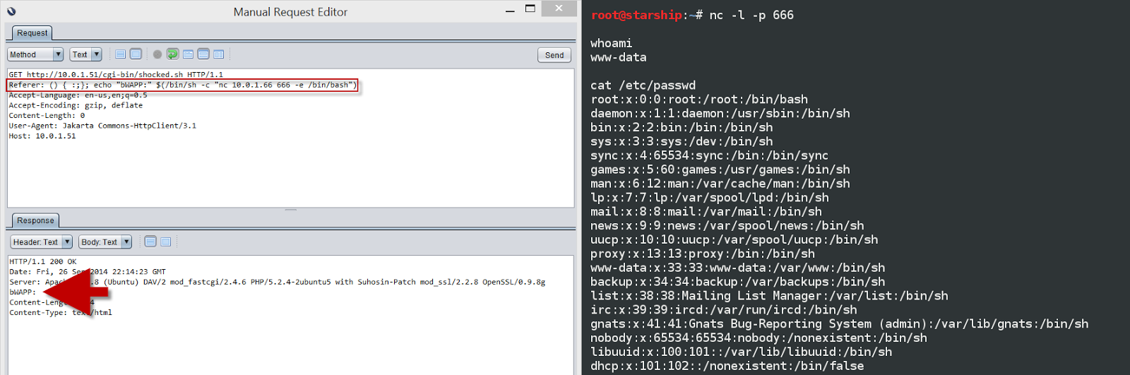
Recommendation:
- Implement role-based access control (RBAC) to ensure users only have access to resources required for their job role.
- Regularly review and update user permissions and access rights.
- Immediately revoke or modify permissions when employees change roles or leave the organization.
- Use automated identity and access management systems integrated with security platforms like Zscaler.
- Conduct periodic security audits to identify and remove unnecessary permissions.

2) Vulnerability Name: Improper Restriction of XML External Entity Reference
CWE NO: CWE-611
OWASP Category: A02:2025 Security Misconfiguration

Description: Improper restriction of XML External Entity (XXE) reference occurs when an application processes XML input without properly disabling or restricting external entity references. XML parsers may allow external entities to access local files, internal systems, or remote resources. If not properly secured, attackers can exploit this vulnerability by injecting malicious XML code to retrieve sensitive information from the server or perform unauthorized actions. This weakness can expose confidential data such as system files, configuration data, or credentials.

Business Impact:
- Exposure of sensitive information such as system files, passwords, or configuration data.
- Unauthorized access to internal systems or network resources.
- Potential data breaches that can damage the organization’s reputation.
- Financial losses due to security incidents or compliance penalties.
- Service disruption if attackers use the vulnerability to perform denial-of-service attacks.

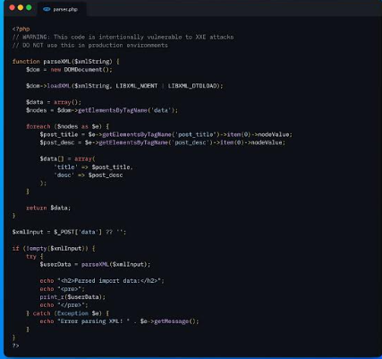
Recommendation:
- Disable external entity processing in XML parsers whenever it is not required.
- Use secure XML parsing libraries that prevent XXE attacks.
- Validate and sanitize all XML input received from users or external sources.
- Apply proper access controls to sensitive files and internal resources.
- Perform regular security testing and vulnerability scanning to detect XXE vulnerabilities early.

3) Vulnerability Name: Reliance on Insufficiently Trustworthy Component
CWE NO: CWE-1357
OWASP Category: A03:2025 Software Supply Chain Failures

Description: Reliance on an insufficiently trustworthy component occurs when a system depends on external or third-party components that may not be secure, reliable, or properly verified. These components can include libraries, APIs, plugins, frameworks, or external services. If such components contain vulnerabilities, outdated code, or malicious functionality, they can compromise the security and performance of the entire system. Organizations must ensure that all components used in their applications or infrastructure are trusted, regularly updated, and securely maintained.

Business Impact:
- Security vulnerabilities that attackers can exploit.
- Unauthorized access to sensitive systems or data.
- System failures or service interruptions.
- Increased risk of malware or malicious code entering the system.
- Financial loss, operational disruption, and damage to company reputation.

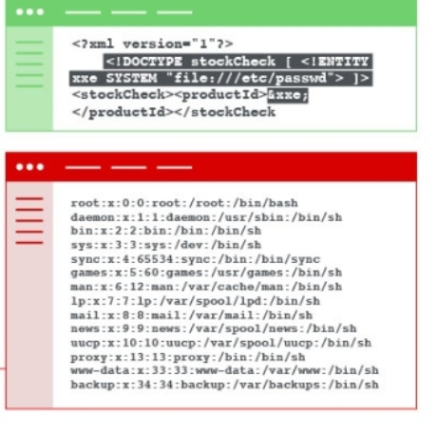
Recommendation:
- Use only trusted and well-maintained third-party components from reliable sources.
- Regularly update and patch all software components and libraries.
- Perform security assessments and vulnerability scans on third-party components.
- Monitor components for known vulnerabilities using security tools.
- Implement strict software supply chain management and approval processes before integrating new components.

4) Vulnerability Name: Use of a Broken or Risky Cryptographic Algorithm
CWE NO: CWE-327
OWASP Category: A04:2025 Cryptographic Failures

Description: The use of a broken or risky cryptographic algorithm occurs when a system relies on outdated or insecure encryption methods to protect sensitive data. Some older cryptographic algorithms have known weaknesses that attackers can exploit to decrypt or manipulate protected information. If these weak algorithms are used for securing data transmission, authentication, or storage, they may fail to provide adequate protection. Therefore, organizations should use modern and secure encryption standards instead of outdated algorithms.

Business Impact:
- Sensitive data such as passwords, financial information, or personal data may be exposed.
- Increased risk of data breaches and cyberattacks.
- Loss of customer trust and damage to the organization's reputation.
- Possible legal or regulatory penalties for failing to protect data properly.
- Financial losses due to security incidents and recovery costs.



Recommendation:
- Avoid using outdated cryptographic algorithms and protocols.
- Implement strong and modern encryption standards such as Advanced Encryption Standard (AES) and Transport Layer Security (TLS).
- Regularly review and update cryptographic mechanisms to follow current security standards.
- Use trusted cryptographic libraries and frameworks.
- Conduct periodic security audits to identify and replace weak encryption algorithms.

5) Vulnerability Name: Improper Neutralization of Special Elements used in an SQL Command ('SQL Injection')
CWE NO: CWE-89
OWASP Category: A05:2025 Injection

Description: Improper neutralization of special elements in an SQL command, commonly known as SQL Injection, occurs when an application does not properly validate or sanitize user input before including it in SQL queries. Attackers can insert malicious SQL code into input fields such as login forms, search boxes, or URL parameters. If the application directly executes this input as part of a database query, the attacker may gain unauthorized access to the database, modify data, or retrieve confidential information.

Business Impact:
- Unauthorized access to sensitive data such as customer information and passwords.
- Manipulation or deletion of important database records.
- Data breaches leading to financial loss and legal consequences.
- Damage to the organization’s reputation and loss of customer trust.
- Possible disruption of business operations if the database is compromised.

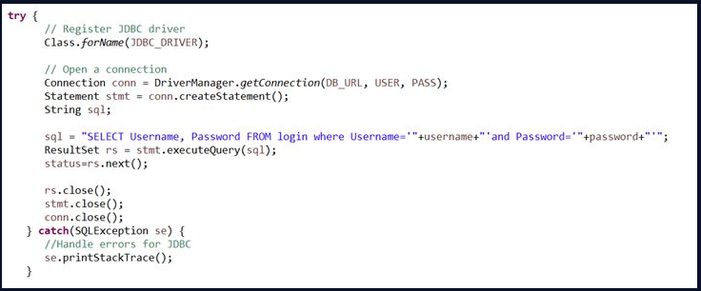

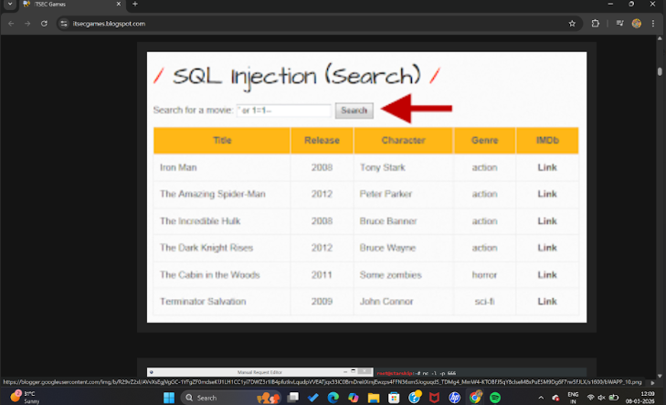

Recommendation:
- Use parameterized queries (prepared statements) instead of dynamic SQL queries.
- Validate and sanitize all user inputs before processing them.
- Implement strong authentication and access control for database systems.
- Use web application firewalls (WAF) to detect and block SQL injection attacks.
- Conduct regular security testing such as vulnerability scanning and penetration testing to identify SQL injection weaknesses.

6) Vulnerability Name: Concurrent Execution using Shared Resource with Improper Synchronization ('Race Condition')
CWE NO: CWE-362
OWASP Category: A06:2025 Insecure Design

Description: A race condition occurs when two or more processes or threads access and modify the same shared resource at the same time without proper synchronization. Because the operations happen concurrently, the final outcome depends on the timing or order of execution. If synchronization mechanisms such as locks, semaphores, or proper thread control are not used, the system may produce incorrect results, inconsistent data, or unexpected behavior.

Business Impact:
- Data corruption or inconsistent database records.
- Unauthorized actions such as multiple transactions being processed incorrectly.
- System instability or application crashes.
- Financial losses due to incorrect processing of transactions.
- Reduced reliability and trust in the system.

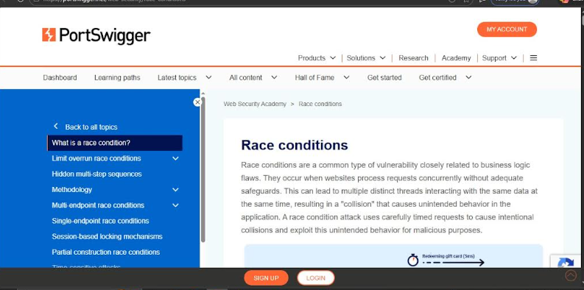

Recommendation:
- Implement proper synchronization mechanisms such as locks, mutexes, or semaphores.
- Ensure that shared resources are accessed in a controlled and sequential manner.
- Use thread-safe programming practices and secure coding standards.
- Perform code reviews and concurrency testing to detect race conditions.
- Apply transaction management and atomic operations when handling critical data.

7) Vulnerability Name: Improper Validation of Certificate with Host Mismatch
CWE NO: CWE-297
OWASP Category: A07:2025 Authentication Failures

Description: Improper validation of a certificate with a host mismatch occurs when a system fails to verify that the hostname in a digital certificate matches the hostname of the server it is connecting to. In secure communications using HTTPS or TLS, the certificate presented by the server should correspond exactly to the domain name requested by the client. If this validation is not properly performed, the system may accept certificates issued for a different host. This can allow attackers to intercept or manipulate communication between the client and server.

Business Impact:
- Increased risk of man-in-the-middle attacks where attackers intercept sensitive data.
- Exposure of confidential information such as login credentials or personal data.
- Compromise of secure communication channels.
- Loss of customer trust due to security weaknesses.
- Potential financial losses and compliance issues if sensitive data is leaked.
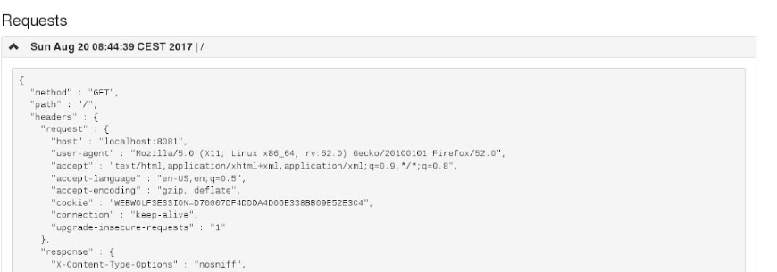
Recommendation:
- Always verify that the certificate’s Common Name (CN) or Subject Alternative Name (SAN) matches the server’s hostname.
- Use properly configured TLS/HTTPS validation mechanisms in applications.
- Avoid disabling certificate validation in production environments.
- Use trusted Certificate Authorities (CAs) to issue and manage certificates.
- Regularly monitor and update security configurations to ensure proper certificate verification.

8) Vulnerability Name: Inclusion of Functionality from Untrusted Control Sphere
CWE NO: CWE-829
OWASP Category: A08:2025 Software or Data Integrity Failures

Description: Inclusion of functionality from an untrusted control sphere occurs when a system or application incorporates code, scripts, or components from sources that are not trusted or not properly verified. These sources may include external libraries, third-party services, plugins, or user-controlled inputs. If these external components are malicious or compromised, they can introduce vulnerabilities, execute unauthorized actions, or allow attackers to control parts of the system. Proper validation and trust management are necessary before integrating such external functionality.

Business Impact:
- Increased risk of malicious code execution within the system.
- Unauthorized access to sensitive data or internal resources.
- System compromise leading to data breaches or service disruption.
- Damage to organizational reputation and customer trust.
- Financial losses due to security incidents and recovery efforts.

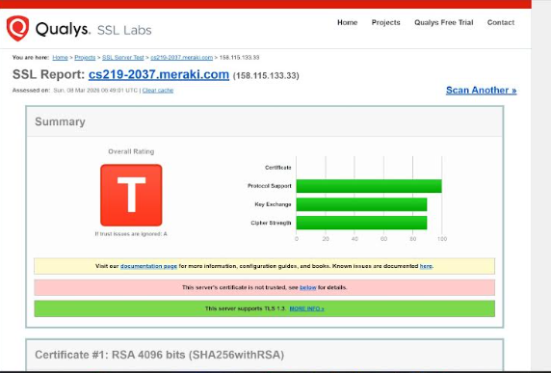

Recommendation:
- Only use trusted and verified third-party components or libraries.
- Validate and sanitize all external inputs before executing them.
- Perform regular security reviews and vulnerability scans of integrated components.
- Maintain strict control over external scripts, plugins, and APIs used in the system.
- Implement strong security policies and monitoring to detect suspicious behavior from external sources.

9) Vulnerability Name: Improper Output Neutralization for Logs
CWE NO: CWE-117
OWASP Category: A09:2025 Security Logging & Alerting Failures

Description: Improper output neutralization for logs occurs when user-controlled input is written to log files without proper validation or sanitization. Attackers can insert malicious characters, commands, or misleading information into the logs. This can lead to log injection, where attackers manipulate log entries to hide their activities, create fake records, or disrupt log analysis systems. If logs are not properly neutralized, it becomes difficult for administrators to accurately monitor system activities and detect security incidents.

Business Impact:
- Attackers may hide malicious activities by altering log records.
- Security teams may receive inaccurate or misleading information during investigations.
- Difficulty in detecting security breaches or suspicious activities.
- Compromised audit trails affecting compliance and forensic analysis.
- Potential operational and financial losses due to delayed incident response.

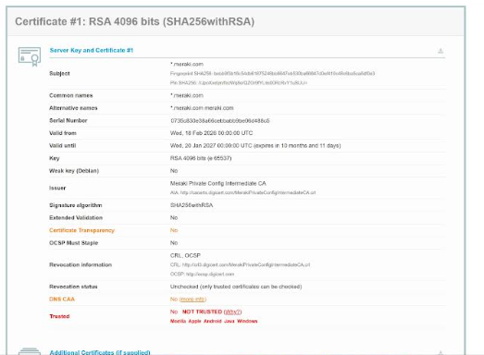

Recommendation:
- Sanitize and validate all user inputs before writing them to log files.
- Encode or escape special characters to prevent log injection attacks.
- Use secure logging frameworks that automatically handle input neutralization.
- Restrict access to log files and monitor them regularly.
- Implement centralized logging and security monitoring systems to detect anomalies.

10) Vulnerability Name: Unchecked Error Condition
CWE NO: CWE-391
OWASP Category: A10:2025 Mishandling of Exceptional Conditions

Description: An unchecked error condition occurs when a program fails to properly check or handle errors that arise during its execution. Errors may occur due to invalid input, system failures, unavailable resources, or unexpected conditions. If the application does not detect and handle these errors correctly, it may continue running in an unstable state, leading to incorrect processing, system crashes, or security vulnerabilities.

Business Impact:
- Application crashes or unexpected system behavior.
- Data corruption or loss of important information.
- Increased security risks if errors expose sensitive system details.
- Service interruptions that affect business operations.
- Reduced user trust and potential financial losses.


Recommendation:
- Implement proper error handling mechanisms in the application code.
- Validate inputs and check return values for all operations.
- Use structured exception handling to manage unexpected conditions.
- Log errors securely without exposing sensitive system information.
- Perform regular testing and code reviews to ensure all possible error conditions are handled properly.

Stage 2

Overview
Nessus Vulnerability Scanner is one of the most widely used tools for identifying security vulnerabilities in computer systems, networks, and applications. It was developed by Tenable, Inc. to help organizations detect weaknesses before attackers can exploit them. Nessus performs automated scans to check systems for security issues such as outdated software, missing patches, configuration errors, and known vulnerabilities.

The scanner works by sending different types of requests to the target system and analyzing the responses. Based on this analysis, it identifies potential security risks and provides detailed reports about the vulnerabilities found. These reports include information about the severity of the vulnerability, its possible impact, and recommendations on how to fix the problem.

Nessus supports multiple scanning methods, including network scanning, host scanning, and compliance checks. It can detect vulnerabilities in operating systems, databases, web servers, and other network devices. The tool uses a regularly updated vulnerability database, which helps it identify newly discovered security threats.

One of the major advantages of Nessus is its easy-to-use interface and detailed reporting system. Security professionals and system administrators use it to monitor and improve the security of their networks. By regularly scanning systems with Nessus, organizations can identify risks early and take corrective actions to protect their data and infrastructure.

Overall, Nessus plays an important role in cybersecurity by helping detect vulnerabilities, reduce security risks, and maintain a safer network environment.

Step-by-Step Explanation of How Nessus Works

Nessus Vulnerability Scanner works by scanning systems and networks to detect security weaknesses. The following steps explain how Nessus performs a vulnerability scan:

1. Installation and Setup
First, the Nessus software is installed on a computer or server. After installation, the user configures the scanner and activates it using a license from Tenable, Inc..

2. Defining Scan Targets
The user specifies the targets to be scanned. These targets can be individual computers, servers, websites, or entire networks. The user can enter IP addresses, hostnames, or network ranges.

3. Selecting Scan Policies
Nessus allows users to choose or create scan policies. These policies define how the scan will be performed, such as the type of vulnerabilities to check, authentication settings, and scanning intensity.

4. Scanning the System
Nessus sends various requests and packets to the target systems. It checks open ports, running services, operating systems, and installed software to detect potential vulnerabilities.

5.Vulnerability Detection
The scanner compares the collected information with its updated vulnerability database. If it finds known weaknesses, such as missing patches or insecure configurations, it identifies them as vulnerabilities.

6. Generating Reports
After completing the scan, Nessus generates detailed reports. These reports include the vulnerability name, severity level (low, medium, high, or critical), description, and possible solutions.

7. Remediation and Security Improvement
System administrators review the report and fix the identified issues by updating software, applying patches, or changing configurations to improve system security.

Benefits of Using Nessus

1. Early Detection of Vulnerabilities
Nessus helps identify security weaknesses before attackers exploit them.

2. Comprehensive Scanning
It can scan networks, operating systems, applications, and databases for a wide range of vulnerabilities.

3. Regular Updates
The vulnerability database is frequently updated to detect newly discovered threats.

4. Detailed Reporting
Nessus provides clear and detailed reports that help administrators understand and fix security issues.

5. User-Friendly Interface
The tool has an easy-to-use interface, making it suitable for both beginners and security professionals.

6. Improves System Security
By regularly scanning systems, organizations can maintain strong cybersecurity and protect sensitive data.

Overall, Nessus is an effective vulnerability scanning tool that helps organizations maintain a secure and reliable network environment.

Target ip address:- 65.61.137.117

List of vulnerability:
S.no | Vulnerability name | severity | plugins
1 | TLS Version 1.0 Protocol Detection | MEDIUM | 104743
2 | SSL/TLS Diffie-Hellman Modulus <= 1024 Bits (Logjam) | LOW | 83875
3 | HTTP Server Type and Version | INFO | 10107
4 | SSL Certificate Information | INFO | 10863
5 | SSL / TLS Versions Supported | INFO | 56984
6 | SSL Certificate Signed Using Weak Hashing Algorithm (Known CA) | INFO | 95631
7 | Service Detection | INFO | 22964
8 | Apache Tomcat Detection | INFO | 39446

1)Vulnerability Name: TLS Version 1.0 Protocol Detection
Severity: MEDIUM
Plugin: 104743
Port: 443
Description:
The remote service accepts connections encrypted using TLS 1.0. TLS 1.0 has a number of cryptographic design flaws. Modern implementations of TLS 1.0 mitigate these problems, but newer versions of TLS like 1.2 and 1.3 are designed against these flaws and should be used whenever possible.
As of March 31, 2020, Endpoints that aren’t enabled for TLS 1.2 and higher will no longer function properly with major web browsers and major vendors.
PCI DSS v3.2 requires that TLS 1.0 be disabled entirely by June 30, 2018, except for POS POI terminals (and the SSL/TLS termination points to which they connect) that can be verified as not being susceptible to any known exploits.

Solution:
Enable support for TLS 1.2 and 1.3, and disable support for TLS 1.0.

Business Impact:
- Data Security Risk
Transport Layer Security version 1.0 is outdated and contains known weaknesses. Attackers may exploit these weaknesses to intercept sensitive data such as login credentials, customer information, or payment details.
- Man-in-the-Middle Attacks
Vulnerabilities such as the BEAST Attack can target TLS 1.0 connections. This may allow attackers to capture or modify encrypted communication between users and servers.
- Compliance and Regulatory Issues
Security standards such as PCI DSS require organizations to disable outdated protocols like TLS 1.0. Continuing to use this protocol may result in compliance violations, penalties, or failed security audits.
- Loss of Customer Trust
If customers discover that a website uses weak encryption protocols, they may lose confidence in the organization’s ability to protect personal and financial information.
- Operational and Financial Impact
A security breach caused by weak encryption can lead to financial loss, legal consequences, incident response costs, and reputational damage.
- Compatibility Issues
Modern browsers and operating systems are increasingly dropping support for TLS 1.0. This may cause service accessibility problems for users and impact business operations.

2)Vulnerability Name: SSL/TLS Diffie-Hellman Modulus <= 1024 Bits (Logjam)
Severity: LOW
Plugin: 83875
Port: 443
Description:
The remote host allows SSL/TLS connections with one or more Diffie-Hellman moduli less than or equal to 1024 bits. Through cryptanalysis, a third party may be able to find the shared secret in a short amount of time (depending on modulus size and attacker resources). This may allow an attacker to recover the plaintext or potentially violate the integrity of connections.

Solution:
Reconfigure the service to use a unique Diffie-Hellman moduli of 2048 bits or greater.

Business Impact:
- Weak Encryption Security
The use of weak parameters in the Diffie-Hellman Key Exchange with modulus sizes of 1024 bits or less makes encrypted communication vulnerable to cryptographic attacks. Attackers may exploit this weakness to break encryption and access sensitive data.
- Man-in-the-Middle Attacks
The Logjam Attack allows attackers to downgrade secure connections to weaker encryption levels. This enables them to intercept and potentially decrypt communications between users and the server.
- Exposure of Sensitive Information
If attackers successfully exploit the vulnerability, confidential information such as user credentials, personal data, and financial transactions may be exposed.
- Compliance and Regulatory Violations
Security standards like PCI DSS require strong encryption for protecting sensitive data. Using weak Diffie-Hellman parameters may lead to compliance failures, security audit issues, and potential penalties.
- Reputational Damage and Loss of Customer Trust
A security incident caused by weak encryption can damage the organization's reputation and reduce customer confidence in the safety of its services.
- Operational and Financial Impact
Security breaches may result in financial losses, legal liabilities, increased remediation costs, and disruption of business operations.

3)Vulnerability Name: HTTP Server Type and Version
Severity: INFO
Plugin: 10107
Port: 443
Description:
HTTP Server Type and Version Disclosure occurs when a web server reveals detailed information about the server software and version in HTTP response headers. For example, the server may expose information such as Apache/2.4.41, Nginx/1.18.0, or Microsoft-IIS/10.0 through the server header. Attackers can use this information to identify known vulnerabilities associated with the specific server version. When server details are publicly exposed, it becomes easier for attackers to target the system with version-specific exploits.

Solution:
To mitigate the risks associated with HTTP server type and version disclosure, organizations should first configure their web servers to hide or modify the “Server” header in HTTP responses.

Business Impact:
- Increased Attack Surface
When attackers know the exact server type and version, they can search for known vulnerabilities and exploit the system more easily.
- Targeted Exploits
Public vulnerability databases such as Common Vulnerabilities and Exposures list vulnerabilities based on software versions. Attackers can use this information to launch targeted attacks against the server.
- Information Leakage
Revealing server details exposes internal infrastructure information that should normally remain hidden from external users.
- Higher Risk of System Compromise
If the server version has known security weaknesses, attackers may exploit them to gain unauthorized access, execute malicious code, or disrupt services.
- Reputation and Financial Impact
Successful attacks due to exposed server information can lead to data breaches, financial loss, and damage to the organization’s reputation.

4)Vulnerability Name: SSL Certificate Information
Severity: INFO
Plugin: 10863
Port: 443
Description:
SSL/TLS certificates are digital certificates used to establish secure communication between a client (such as a web browser) and a server. They provide authentication, data integrity, and encryption to protect information transmitted over the network. Improper management or exposure of SSL certificate information can pose security risks. For example, if certificate details such as the issuer, expiration date, or cryptographic algorithms are outdated or misconfigured, attackers can exploit these weaknesses to intercept or manipulate encrypted communications. Vulnerabilities may include weak key sizes, expired certificates, use of insecure algorithms, or certificates issued by untrusted authorities.

Solution:
To ensure the security and integrity of SSL/TLS communications, organizations should implement a robust certificate management strategy.

Business Impact:
- Data Security Risk
Weak or misconfigured certificates can allow attackers to decrypt sensitive communications, leading to exposure of customer data, login credentials, or financial transactions.
- Man-in-the-Middle Attacks
Attackers can exploit certificate weaknesses to perform man-in-the-middle attacks, intercepting and altering communications between clients and servers.
- Compliance and Regulatory Issues
Organizations may fail to meet standards such as PCI DSS, HIPAA, or GDPR if SSL certificates are improperly managed, resulting in audit failures and potential fines.
- Reputation and Trust Loss
Security breaches or browser warnings due to invalid or expired certificates can damage customer confidence and harm the organization’s reputation.
- Operational and Financial Impact
Remediation of SSL-related vulnerabilities, including reissuing certificates and addressing breaches, can lead to operational disruption and financial costs.

5)Vulnerability Name: SSL / TLS Versions Supported
Severity: INFO
Plugin: 56984
Port: 443
Description:
SSL and TLS are cryptographic protocols used to secure communications over networks, ensuring confidentiality, integrity, and authentication. When a server supports outdated versions of these protocols, such as SSL 2.0, SSL 3.0, or TLS 1.0, it exposes the system to known vulnerabilities and attacks, including POODLE, BEAST, and downgrade attacks. Supporting multiple outdated versions increases the risk that attackers can force a connection to use a weak protocol, compromising encrypted communications.

Solution:
Organizations should disable all insecure SSL/TLS versions and configure their servers to support only modern, secure protocols such as TLS 1.2 and TLS 1.3. Regular security assessments should be conducted to verify protocol configurations and detect any legacy or weak protocols.

Business Impact:
- Data Breach Risk – Weak protocols like SSL 2.0, SSL 3.0, or TLS 1.0 can be exploited to intercept sensitive information such as customer credentials, payment details, and confidential business data.
- Regulatory Non-Compliance – Using insecure protocols may violate standards like PCI DSS, HIPAA, or GDPR, resulting in audit failures, fines, or legal liability.
- Loss of Customer Trust – Public knowledge of insecure encryption can damage the organization’s reputation and reduce confidence in its services or products.
- Financial Loss – Security incidents stemming from outdated protocols can lead to remediation costs, legal fees, and operational downtime.
- Vulnerability to Targeted Attacks – Attackers can leverage protocol weaknesses to perform man-in-the-middle attacks, downgrade attacks, or data tampering, increasing overall organizational risk.

6)Vulnerability Name: SSL Certificate Signed Using Weak Hashing Algorithm (Known CA)
Severity: INFO
Plugin: 95631
Port: 443
Description:
The remote service uses a known CA certificate in the SSL certificate chain that has been signed using a cryptographically weak hashing algorithm (e.g., MD2, MD4, MD5, or SHA1). These signature algorithms are known to be vulnerable to collision attacks (CVE-2004-2761, for example). An attacker can exploit this to generate another certificate with the same digital signature, allowing the attacker to masquerade as the affected service.
Note that this plugin reports all SSL certificate chains signed with SHA-1 that expire after January 1, 2017 as vulnerable. This is in accordance with Google's gradual sunsetting of the SHA-1 cryptographic hash algorithm.
Note that this plugin will only fire on root certificates that are known certificate authorities as listed in Tenable Community Knowledge Article 000001752. That is what differentiates this plugin from plugin 35291, which will fire on any certificate, not just known certificate authority root certificates.
Known certificate authority root certificates are inherently trusted and so any potential issues with the signature, including it being signed using a weak hashing algorithm, are not considered security issues.

Solution:
Contact the Certificate Authority to have the certificate reissued.

Business Impact:
- Data Security Risk – Certificates signed with weak hashing algorithms, such as MD5 or SHA-1, can be forged or tampered with. This undermines the integrity of encrypted communications and exposes sensitive information such as login credentials, financial data, or confidential business information to interception.
- Man-in-the-Middle Attacks – Attackers can exploit weak certificate signatures to create fraudulent certificates and perform man-in-the-middle attacks, intercepting or modifying traffic between clients and servers without detection.
- Regulatory and Compliance Issues – Organizations may fail to comply with security standards such as PCI DSS or GDPR, which require strong cryptographic practices. Non-compliance can lead to penalties, failed audits, or legal liabilities.
- Reputation and Customer Trust – If clients or partners discover that communications rely on weak certificate signatures, the organization’s credibility and trustworthiness may be severely damaged, impacting customer retention and business relationships.
- Operational and Financial Impact – Addressing security breaches or remediating weak certificates can result in operational disruption, emergency re-issuance of certificates, increased IT costs, and potential financial losses due to fraud or litigation.
- Using weak hashing algorithms in SSL certificates poses a significant risk to data security, regulatory compliance, and organizational reputation, making timely replacement with certificates signed using strong algorithms (e.g., SHA-256 or higher) critical.

7)Vulnerability Name: Service Detection
Severity: INFO
Plugin: 22964
Port: 443
Description:
Service detection occurs when network scanners or attackers can identify active services, their versions, and the protocols running on a system. This is typically revealed through open ports, banners, or other network responses. Information such as web servers, database servers, SSH, FTP, or SMTP versions can be exposed. While service detection itself is not an exploit, it provides attackers with valuable intelligence that can be used to target known vulnerabilities associated with specific services or versions.

Solution:
To mitigate the risks associated with service detection, organizations should implement strict network and service management practices.

Business Impact:
- Increased Attack Surface – Exposed services allow attackers to map the network and identify potential entry points for exploitation.
- Targeted Exploits – Knowledge of service versions enables attackers to leverage publicly known vulnerabilities, increasing the likelihood of successful attacks.
- Data Breach Risk – Compromised services can lead to unauthorized access to sensitive data, including customer information, financial records, or proprietary business data.
- Compliance and Regulatory Issues – Organizations may fail to meet security standards such as PCI DSS or ISO 27001 if unnecessary services are exposed.
- Reputation and Financial Impact – Successful attacks resulting from exposed services can cause financial loss, service disruption, and reputational damage.

8)Vulnerability Name: Apache Tomcat Detection
Severity: INFO
Plugin: 39446
Port: 443
Description:
Apache Tomcat Detection occurs when a web server or application server is identified as running Apache Tomcat, typically through HTTP headers, error messages, default pages, or open ports. Apache Tomcat is a widely used Java-based web application server, and detecting its presence can provide attackers with information about the server environment. If the version of Tomcat is also disclosed, attackers can target known vulnerabilities specific to that version, such as remote code execution, directory traversal, or misconfigured management interfaces. Even detection alone can assist attackers in planning targeted attacks.

Solution:
To mitigate the risks associated with Apache Tomcat detection, organizations should first remove or modify server banners and default pages that reveal Tomcat’s presence or version. Unused Tomcat services, default applications, and example files should be deleted or disabled. The server must be kept up to date with the latest patches, and access to administrative interfaces should be restricted through firewalls or network segmentation.

Business Impact:
- Targeted Attacks – Knowledge that the server runs Apache Tomcat allows attackers to focus on known vulnerabilities or exploits for specific versions.
- Data Breach Risk – Exploiting Tomcat vulnerabilities may provide unauthorized access to application data, sensitive customer information, or internal systems.
- Compliance and Regulatory Issues – Exposed services may violate security standards such as PCI DSS or ISO 27001, potentially leading to failed audits or fines.
- Reputation and Customer Trust – A successful breach due to detectable or misconfigured servers can damage organizational credibility and trust.
- Operational and Financial Impact – Exploitation may result in downtime, incident response costs, and remediation expenses.

Stage 3

Title: Implement and Manage Zero Trust Network Access (ZTNA) using Zscaler

1. Zero Trust Network Access (ZTNA)

Zero Trust Architecture is a modern cybersecurity approach that assumes no user or device should be trusted automatically, whether they are inside or outside the organization's network. Every access request must be verified before granting access to applications or resources.

Zero Trust Network Access is a security model that provides secure access to applications by verifying identity, device health, and security policies before allowing connection. Unlike traditional security models that rely on Virtual Private Networks (VPNs), ZTNA connects users directly to specific applications instead of the entire network.

The main principle of ZTNA is “Never Trust, Always Verify.” This means every user must authenticate themselves each time they request access. The system checks multiple factors such as user identity, device status, location, and security posture before allowing access.

ZTNA also uses least privilege access, meaning users can only access the resources necessary for their work. This reduces the risk of attackers moving across the network if a user account is compromised.

Another important feature of ZTNA is continuous monitoring. Even after access is granted, the system constantly monitors user activity and device behavior. If suspicious activity is detected, access may be restricted or terminated.

ZTNA is widely used in organizations to protect cloud applications, internal systems, and sensitive data. It is especially useful for companies that support remote work and cloud-based services.

Overall, ZTNA improves cybersecurity by reducing attack surfaces, preventing unauthorized access, and ensuring that only verified users and devices can access organizational resources.

2. Zscaler then Enforces Policies Based on this Data

Zscaler Zero Trust Exchange collects various types of data before granting access to applications. Based on this information, the system enforces security policies to ensure that only authorized users can access resources.

The platform gathers several types of information including user identity, device health, location, network status, and security posture. This data is used to evaluate whether the access request is safe.

Zscaler uses policy enforcement to control how users interact with applications. These policies are created by administrators and define rules for secure access.

For example, policies may allow access only if:

- The user is authenticated.

- The device meets security requirements.

- The user is accessing from a trusted location.

- The device has updated security software.

If any of these conditions are not met, access can be restricted or denied. This helps prevent unauthorized users or compromised devices from entering the network.

Zscaler policies also control the level of access granted. Instead of giving users full network access, they are allowed to connect only to specific applications they are authorized to use. This reduces security risks and protects sensitive information.

The system continuously monitors user activity and device behavior. If suspicious activity is detected, the platform can automatically apply new security policies such as blocking access or requiring additional authentication.

By enforcing policies based on real-time data, Zscaler ensures strong security and protects applications from cyber threats.

3. The Zscaler ZTNA Cycle

The ZTNA cycle represents the continuous process of verifying identity, granting secure access, monitoring activity, and improving security policies.

In the Zscaler environment, the ZTNA cycle includes several important steps that work together to maintain secure access.

1. User Authentication

The process begins when a user attempts to access an application. The system verifies the user’s identity through authentication methods such as username and password or multi-factor authentication.

2. Device Verification

The platform checks the security status of the device. This may include checking operating system updates, antivirus software, and device configuration.

3. Policy Evaluation

Once identity and device information are verified, Zscaler evaluates the access request using predefined security policies. These policies determine whether access should be allowed or denied.

4. Secure Application Connection

If all conditions are satisfied, the user is granted secure access directly to the required application instead of the entire network.

5. Continuous Monitoring

Even after access is granted, the system continuously monitors user activity and network traffic to detect suspicious behavior.

6. Policy Improvement

Based on monitoring results and threat intelligence, security policies are updated to improve protection against new threats.

This continuous cycle ensures that security is maintained at every stage of user access.

4. Threat Intelligence

Threat Intelligence refers to the collection and analysis of information about potential or existing cyber threats. It helps organizations understand attack patterns, vulnerabilities, and malicious activities.

Threat intelligence provides valuable insights into how cybercriminals operate and what types of attacks they may launch. This information allows organizations to prepare defenses before attacks occur.

In ZTNA environments, threat intelligence plays an important role in identifying suspicious activity. Security platforms analyze data from various sources such as:

- Network traffic

- Security logs

- Malware databases

- Global threat reports

Zscaler uses its cloud platform to collect threat data from millions of users and networks around the world. This global data helps identify new threats quickly and protect organizations from emerging cyber attacks.

Threat intelligence is used to update security policies, detect malicious websites, block malware downloads, and identify compromised devices.

By integrating threat intelligence with ZTNA systems, organizations can proactively defend against cyber threats and reduce security risks.

5. Incident Response (Adapted for ZTNA)

Incident Response is the process of identifying, managing, and resolving cybersecurity incidents such as data breaches, malware infections, or unauthorized access.

In a Zero Trust environment, incident response strategies are designed to quickly detect and respond to security threats without affecting normal operations.

The incident response process in ZTNA environments typically includes the following stages:

1. Detection

Security monitoring systems detect unusual behavior or suspicious activities in the network.

2. Investigation

Security teams analyze logs, alerts, and network activity to determine the cause of the incident.

3. Containment

The system restricts access for affected users or devices to prevent the attack from spreading.

4. Remediation

Security teams fix the vulnerability or remove the malicious software that caused the incident.

5. Recovery

Systems are restored to normal operation after the issue is resolved.

6. Review and Improvement

The organization analyzes the incident and updates security policies to prevent similar attacks in the future.

ZTNA makes incident response more effective because it limits access to specific applications and continuously monitors activity.

6. Understanding the Tool (Zscaler ZPA)

Zscaler Private Access is a cloud-based security solution that enables secure remote access to internal applications without using traditional VPN technology.

ZPA connects users directly to applications through the Zscaler cloud platform while keeping internal networks hidden from the internet. This significantly reduces the risk of cyber attacks.

The tool works using three main components:

1. Zscaler Client Connector

This software is installed on the user’s device and creates a secure connection to the Zscaler cloud.

2. ZPA App Connector

This component is installed in the organization's data center or cloud environment and connects internal applications to the Zscaler platform.

3. Zscaler Cloud Platform

The cloud platform controls access, verifies user identity, and enforces security policies.

When a user tries to access an application, ZPA verifies identity and device status before allowing connection. If the request meets security policies, the user is granted access only to that specific application.

ZPA also provides features such as secure remote access, application segmentation, continuous monitoring, and strong encryption.

Overall, Zscaler ZPA is an important tool for implementing Zero Trust security and protecting enterprise applications from unauthorized access.

Conclusion

Implementing Zero Trust Network Access (ZTNA) using Zscaler provides organizations with a modern and secure approach to protecting applications, users, and data in today’s distributed IT environments. Unlike traditional perimeter-based security models, ZTNA operates on the principle of “never trust, always verify,” ensuring that every access request is authenticated, authorized, and continuously validated.
Through Zscaler’s cloud-native architecture, organizations can securely connect users to internal applications without exposing the network to the internet. Features such as identity-based access control, application segmentation, continuous monitoring, and encrypted connections help reduce the attack surface and prevent unauthorized access. This approach is especially valuable for remote workforces, cloud applications, and hybrid infrastructures.
Effective management of ZTNA with Zscaler also involves proper policy configuration, integration with identity providers, regular monitoring of user activity, and continuous security assessments. By implementing these best practices, organizations can maintain strong visibility and control over who accesses critical resources and under what conditions.
In conclusion, adopting ZTNA through Zscaler not only enhances network security but also improves scalability, user experience, and operational efficiency. As cyber threats continue to evolve, Zero Trust frameworks supported by platforms like Zscaler will remain essential for building resilient and future-ready security architectures.

In Stage 1, vulnerabilities were intentionally created based on the OWASP Top 10. The OWASP Top 10 is a globally recognized standard that lists the most critical security risks found in web applications. Some common vulnerabilities included in this list are injection attacks, broken authentication, sensitive data exposure, security misconfiguration, and cross-site scripting. By creating these vulnerabilities in the application, it helped in understanding how security weaknesses can occur due to improper coding practices, weak authentication mechanisms, or poor configuration settings. Screenshots and reports were documented during this stage to clearly demonstrate how these vulnerabilities appear in a system and how attackers might exploit them. This stage provided practical knowledge about the importance of secure coding practices and proper system configuration to prevent vulnerabilities.

In Stage 2, the vulnerabilities created in the first stage were analyzed and detected using the Nessus Vulnerability Scanner. Nessus is a powerful vulnerability scanning tool that helps security professionals identify weaknesses in networks, systems, and applications. After installing and configuring the scanner, the vulnerable application was scanned to detect security issues. During the scanning process, Nessus examined the system for open ports, running services, outdated software versions, and other potential security risks. The tool generated detailed reports containing information about the vulnerabilities discovered, including the port numbers associated with vulnerable services, the severity level of each vulnerability, and recommendations for fixing them. This stage helped demonstrate how vulnerability scanning tools work in real-world cybersecurity environments and how they assist security administrators in identifying and managing risks. It also highlighted the importance of regular security scanning to maintain a secure network infrastructure.

In Stage 3, the focus shifted from vulnerability detection to implementing modern security solutions to prevent unauthorized access. This stage involved understanding the concept of Zero Trust Architecture and how it can be implemented using Zscaler Private Access. The Zero Trust security model follows the principle of “never trust, always verify,” meaning that no user or device is automatically trusted, regardless of whether they are inside or outside the organization’s network. Every access request must go through authentication, authorization, and policy verification before access is granted. Zscaler Private Access provides secure application access without exposing internal networks to the internet. It connects users directly to specific applications through a secure cloud platform and enforces security policies based on user identity, device health, and location. This stage also included concepts such as threat intelligence, incident response, policy enforcement, and continuous monitoring to ensure strong protection against cyber threats.

Overall, the three stages of this project provided a comprehensive understanding of cybersecurity practices. The first stage focused on creating and understanding vulnerabilities, the second stage demonstrated how these vulnerabilities can be detected using scanning tools, and the third stage explained how modern security frameworks and technologies can protect systems from potential attacks. By completing these stages, it becomes clear that effective cybersecurity requires a combination of vulnerability identification, continuous monitoring, and advanced security solutions. Implementing these practices helps organizations protect their systems, applications, and sensitive data from cyber threats while ensuring a secure and reliable digital environment.

Future Scope

1. Future Scope of Web Application Testing

OWASP Top 10 has highlighted how web applications are common targets for cyber attacks. As organizations increasingly depend on web-based platforms such as e-commerce websites, banking systems, and cloud services, web application testing will become more important in the future.

The future scope of web application testing is expanding because modern applications are more complex and connected to many systems. Applications today use cloud services, APIs, microservices, and mobile platforms. This complexity increases the chances of vulnerabilities. Therefore, organizations must continuously test their web applications to ensure they are secure and reliable.

In the future, automated security testing tools will become more widely used. These tools can automatically scan applications for vulnerabilities, detect coding errors, and provide suggestions for fixing security issues. Automation will make testing faster and more efficient compared to manual testing.

Another important future development is the integration of security testing into the software development lifecycle. Instead of testing applications only after development, security testing will be performed during each stage of development. This approach is often called DevSecOps, where security practices are integrated into development and operations.

Artificial intelligence and machine learning will also improve web application testing. Intelligent systems will analyze application behavior and detect unusual activities that may indicate security threats. These technologies will help identify vulnerabilities that traditional testing methods might miss.

With the growth of cloud computing and remote access, web application testing will focus more on protecting user data, authentication systems, and APIs. Organizations will need strong testing methods to prevent attacks such as SQL injection, cross-site scripting, and authentication bypass.

Overall, the future scope of web application testing is very promising. As web technologies continue to evolve, testing practices will also advance to ensure applications remain secure, reliable, and efficient.

2. Future Scope of Testing Process

The testing process is an important part of software development that ensures applications work correctly, securely, and efficiently. In the future, the testing process will become more advanced due to new technologies, automation tools, and changing software development methods.

One major change in the future testing process will be increased automation. Automated testing tools can quickly test large applications, detect bugs, and generate reports. Automation reduces human errors and improves testing efficiency. Many organizations are already using automated testing frameworks to speed up development cycles.

Another important development is continuous testing. In modern development environments, software is updated frequently. Continuous testing ensures that every new update is tested automatically before it is deployed. This approach improves software quality and reduces the chances of errors reaching the final product.

The testing process will also focus more on security testing. As cyber threats continue to grow, testing processes must include vulnerability assessments, penetration testing, and risk analysis. Security testing will become a standard practice in all software projects.

Artificial intelligence will also influence the testing process. AI-powered testing tools will be able to predict potential issues, identify risky areas in the code, and suggest test cases automatically. This will improve the accuracy and effectiveness of the testing process.

Another important aspect of the future testing process is user experience testing. Applications must not only function correctly but also provide a smooth and user-friendly experience. Testing methods will include usability testing, performance testing, and accessibility testing.

Overall, the testing process will become more automated, intelligent, and integrated with development workflows. These improvements will help organizations develop high-quality, secure, and reliable software systems.

3. Future Scope of SOC / SIEM

Security Operations Center (SOC) is a centralized facility where security professionals monitor and manage cybersecurity threats within an organization.

Security Information and Event Management (SIEM) is a technology that collects, analyzes, and monitors security data from various sources such as servers, networks, and applications.

The future scope of SOC and SIEM is growing rapidly because organizations are facing increasing cyber threats such as ransomware, phishing attacks, and data breaches. Companies need advanced monitoring systems to detect and respond to these threats quickly.

In the future, SOC operations will rely heavily on automation and artificial intelligence. Automated systems will analyze large volumes of security data and detect suspicious activities in real time. This will help security teams respond to incidents more quickly and effectively.

Another important development will be cloud-based SOC solutions. Many organizations are moving their infrastructure to the cloud, so SOC systems must adapt to monitor cloud environments. Cloud-based SIEM tools will provide centralized monitoring and improved scalability.

The future SOC will also focus on threat intelligence integration. By collecting data from global threat intelligence sources, SIEM systems will be able to identify emerging threats and protect organizations from new types of cyber attacks.

Additionally, SOC teams will increasingly use behavior analytics to detect unusual user activities. For example, if a user suddenly accesses sensitive data from a different location or device, the system will generate alerts for further investigation.

Overall, the future of SOC and SIEM will involve advanced technologies, automated threat detection, and stronger integration with cloud environments to improve cybersecurity monitoring and incident response.

4. Topics Explored

During the project, several important cybersecurity topics were explored to understand vulnerability management, security testing, and modern protection methods.

The concept of Zero Trust Network Access (ZTNA) has become a critical component in modern cybersecurity strategies. Traditional security models relied heavily on perimeter-based defenses, where users and devices inside the corporate network were automatically trusted. However, with the rise of cloud computing, remote work, mobile devices, and sophisticated cyber threats, this approach is no longer sufficient. ZTNA addresses these challenges by adopting the principle of “never trust, always verify,” ensuring that every user, device, and application request is continuously authenticated and authorized before access is granted.
One of the leading platforms that supports the implementation of ZTNA is Zscaler. Zscaler provides a cloud-native security platform that enables secure access to both internet and private applications without exposing the internal network. By shifting security controls from traditional hardware appliances to a globally distributed cloud platform, organizations can achieve better scalability, flexibility, and performance while maintaining strong security controls.
A major component of ZTNA implementation is Zscaler Private Access. This solution allows users to connect directly to specific internal applications rather than the entire network. Unlike VPN-based access, which can expose the network to potential threats, ZPA creates secure, outbound-only connections between users and applications. This architecture eliminates the risk of lateral movement within the network and significantly reduces the attack surface.
Another important service in the Zscaler platform is Zscaler Internet Access. This tool acts as a cloud-based secure web gateway that protects users from malicious websites, malware, phishing attacks, and other online threats. It inspects internet traffic in real time and enforces security policies to ensure safe access to web resources and SaaS applications.
Endpoint security also plays a crucial role in a Zero Trust environment. The Zscaler Client Connector is installed on user devices such as laptops, desktops, and mobile devices. This software establishes a secure tunnel between the device and the Zscaler cloud platform, ensuring that all traffic is inspected and controlled according to the organization’s security policies. It also helps verify device posture and ensures that only compliant devices can access corporate resources.
Identity verification is another key pillar of the Zero Trust model. Zscaler integrates with identity providers such as Microsoft Entra ID and Okta to authenticate users before granting access to applications. By leveraging identity-based access control, organizations can implement policies that consider user identity, device health, location, and other contextual factors.
Managing ZTNA with Zscaler involves continuous monitoring and policy management through the centralized administrative portal. Security administrators can define access policies, monitor user activity, analyze traffic patterns, and generate detailed security reports. These insights help organizations quickly detect suspicious behavior, respond to potential threats, and maintain compliance with security standards.
ZTNA also enhances network segmentation by allowing organizations to define granular access policies. Instead of granting broad network access, administrators can restrict users to only the applications they need for their roles. This micro-segmentation approach limits the impact of potential security breaches and protects sensitive data from unauthorized access.
In addition to improved security, ZTNA with Zscaler also offers operational benefits. Because the platform is cloud-based, organizations do not need to maintain complex hardware infrastructure or traditional VPN gateways. This simplifies deployment, reduces operational costs, and ensures that users can securely access applications from anywhere with minimal latency.
Overall, the implementation and management of Zero Trust Network Access using Zscaler represent a significant advancement in enterprise cybersecurity. By combining identity-based access control, cloud-native architecture, secure application connectivity, and continuous monitoring, organizations can protect their digital assets while enabling secure and efficient access for modern work environments.

Threat intelligence and incident response were also studied to understand how organizations detect and respond to cyber attacks. These concepts help security teams identify threats quickly and take appropriate action to minimize damage.
Overall, exploring these topics helped build a strong understanding of cybersecurity practices, vulnerability management, and modern security frameworks used in organizations.

5. Tools Explored

Several cybersecurity tools were explored during the project to understand vulnerability detection, scanning, and security analysis.
The implementation of Zero Trust Network Access (ZTNA) using Zscaler involves several tools that help in configuring, monitoring, and managing secure access to applications. One of the key tools is Zscaler Private Access, which enables secure remote access to internal applications without exposing the organization’s network to the internet. It connects authenticated users directly to specific applications based on defined access policies. Another important tool is Zscaler Internet Access, which acts as a secure web gateway that protects users from cyber threats while accessing internet and SaaS applications. Additionally, Zscaler Client Connector is used on endpoint devices to establish a secure connection between the user and the Zscaler cloud platform. These tools work together to enforce identity-based access, monitor network activity, and ensure that only authorized users can access organizational resources, thereby supporting a strong Zero Trust security model.

Nessus Vulnerability, ScannerZscaler Private Access, OWASP ZAP, Burp Suite, Wireshar, kMetasploit, Framework, Kali Linux.

